CEVP Impact Analysis

Studying the impact of San Jose Fire’s Centralized Emergency Vehicle Pre-Emption system on emergency vehicle travel time

Fire Department Data Story

Albert Gehami, Data Scientist, Friday, May 24, 2019

In October of 2018 San Jose introduced an emergency vehicle pre-emption system into their traffic lights.[1] As an emergency vehicle approaches an intersection, the stop light will turn green for the emergency vehicle, and red for the opposing traffic to clear the intersection for the emergency vehicle to pass through. The traffic light pre-emption is designed to get vehicles to emergencies faster. Anecdotally, this system has been a game-changer for emergency vehicles, but there has been no analysis on how much time is saved from the traffic light pre-emption system.

In 2018, passing through an intersection would add 6-8 seconds to an emergency vehicle’s travel time. Once CEVP was fully implemented, an intersection only added, on average, 1 second. The traffic light pre-emption system appears to reduce average travel time by 5-7 seconds per intersection (Figure 1).

Figure : Seconds added to overall travel time for each San Jose-owned intersection before and after CEVP was fully implemented.

One of the more common emergency trips for a fire truck is from the Fire Station near Tully and Senter Rd to the area near Little Orchard and Cimino Street (Figure 2). This trip’s distance is 1.5 miles, and includes 6 intersections owned by San Jose. It was taken 455 times as a code 3 (highest emergency) trip from January 1st 2018 to April 31st 2019, with 451 verified start and end times. Before CEVP, this trip would take, on average, 8 minutes and 38 seconds. After CEVP was fully implemented, this trip would take on average 6 minutes and 51 seconds, a reduction of 107 seconds.

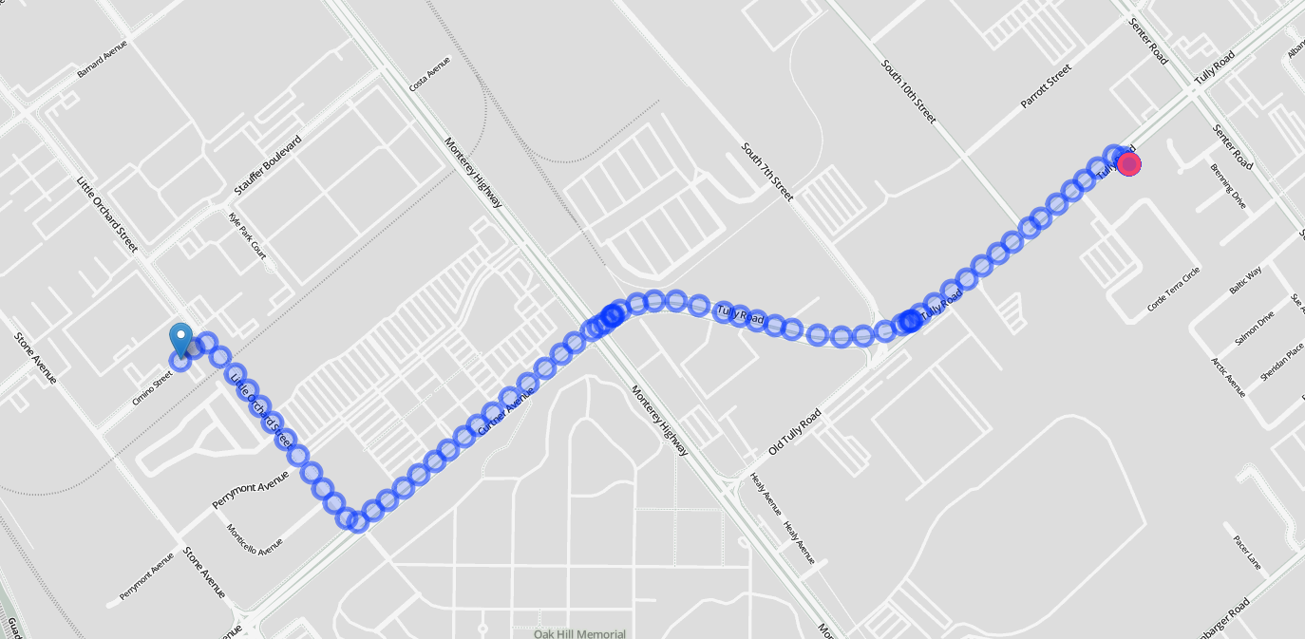

Figure : The route from the Fire Station near Tully and Senter Rd to the area near Little Orchard and Cimino Street. This trip took, on average, a minute less after San Jose fully implemented CEVP.

The Fire department has been raving over the new CEVP system, and for good reason. Intersections used to take substantial time to get through, but now they take almost no time at all. With the average emergency vehicle trip passing through 4 intersections, an average of 20-28 seconds is saved per trip because of CEVP. A fire can engulf a house within 2 minutes after the smoke alarm goes off, [2],[3],[4] so 24 seconds saved can be critical to stopping a house fire. For medical calls, 24 seconds saved can lead to a 1-2% decrease in mortality rate for heart attack victims.[5] For trips that cover substantially more intersections, the reduced travel time can save even more lives.

1. “San Jose Integrates Emergency Vehicle Pre-Emption with CAD System.” *Radio Resource*, 1 Oct. 2018, www.rrmediagroup.com/News/NewsDetails/NewsID/17424.
2. “Home Fires.” Home Fires | Ready.gov, www.ready.gov/home-fires.
3. “How Quickly Does Fire Spread?” *Disaster Company*, 3 Oct. 2017, www.disastercompany.com/quickly-fire-spread/.
4. Robert, Crandall. “How Fast Is Fire?” *Fire Event Timeline | Home Fire Drill | Prevention 1st Foundation*, 2005, www.homefiredrill.org/?p=fire-event-timeline.
5. Based on research by Anupam et al (2017).